Dayananda Sagar College of Engineering

**Department of Electronics and Communication Engineering**

**ShavigeMalleshwara Hills, Kumaraswamy Layout, Bangalore – 560 078.**

**(An Autonomous Institute affiliated to VTU, Approved by AICTE & ISO 9001:2008 Certified)**

***Accredited by National Assessment and Accreditation Council (NAAC) with ‘A’ grade***

**OPEN ENDED EXPERIMENT**

**INTEGRATED PRINCIPLES OF COMMUNICATION THEORY LAB**

|  |  |
| --- | --- |
| Program: B.E. | Branch: ECE |
| Course: Principles of Communication Theory | Semester : IV |
| Course Code: 22EC44 | Date: |

**A Report on**

OPEN ENDED EXPERIMENT

**TOPIC**

**PULSE POSITION MODULATION AND DEMODULATION**

**Submitted by**

|  |  |  |  |
| --- | --- | --- | --- |
| **Sl.No.** | **USN** | **NAME** | **MARKS** |
| **1.** | **1DS22EC054** | **CHAITRA KRISHNA GOUDA** |  |
| **2.** | **1DS22EC057** | **CHARAN. S** |  |
| **3** | **1DS22EC058** | **CHITHRASHREE .G. S** |  |

Faculty In-charge

Prof.Naveen.K.N

Prof.Ravi Kumar S

**Signature of Faculty In-charge**

**INTRODUCTION:**

* Pulse Modulation is used to transmit analog information in this system continuous wave forms are sampled at regular intervals. Information regarding the signal is transmitted only at the sampling times together with synchronizing signals.
* At the receiving end, the original waveforms may be reconstituted from the information regarding the samples.
* Pulse modulation may be subdivided in to two types analog and digital. In analog the indication of sample amplitude is the nearest variable. In digital the information is a code.
* The pulse position modulation is one of the methods of the pulse time modulation. PPM is generated by changing the position of a fixed time slot.
* The amplitude& width of the pulses is kept constant, while the position of each pulse, in relation to the position of the recurrent reference pulse is valid by each instances sampled value of the modulating wave.
* Pulse position modulation into the category of analog communication. Pulse-Position modulation has the advantage of requiring constant transmitter power output, but the disadvantage of depending on transmitter receiver synchronization.
* Pulse-position modulation may be obtained very simply from PWM. However, in PWM the locations of the leading edges are fixed, whereas those of the trailing edges are not. Their position depends on pulse width, which is determined by the signal amplitude at that instant. Thus, it may be said that the trailing edges of PWM pulses are, in fact, position-modulated. This has positive-going narrow pulses corresponding to leading edges and negative-going pulses corresponding to trailing edges. If the position corresponding to the trailing edge of an un modulated pulse is counted as zero displacement, then the other trailing edges will arrive earlier or later. They will therefore have a time displacement other than zero; this time displacement is proportional to the instantaneous value of the signal voltage. The differentiated pulses corresponding to the leading edges are removed with a diode clipper or rectifier, and the remaining pulses, is position-modulated
* PPM is used in various wireless communication systems where it can efficiently transmit digital data over radio frequency (RF) channels. It's particularly useful in applications where the bandwidth is limited.
* In optical communication systems, PPM can be employed to encode data onto optical pulses transmitted through fiber optic cables. Its ability to handle noise and its bandwidth efficiency make it suitable for high-speed data transmission.

**PROGRAM:-**

% pulse position modulation

close all

clear all

clc

fc=100;

fs=1000;

f1=80;

t=0:1/fs:((2/f1)-(1/fs));

x1=0.4*cos(2*pi*f1*t)+0.5;

%modulation

y1=modulate(x1,fc,fs,'ppm');

subplot(311);

plot(x1);

axis([0 15 0 1]);

title('original signal taken mesage,f1=80,fs=1000')

subplot(312);

plot(y1);

axis([0 250 -0.2 1.2]);

title('PPM')

%demodulation

x1_recov=demod(y1,fc,fs,'ppm');

subplot(313);

plot(x1_recov);

title('time domain recovered, single tone,f1=80')

axis([0 15 0 1]);

**CIRCUIT DIAGRAM**:

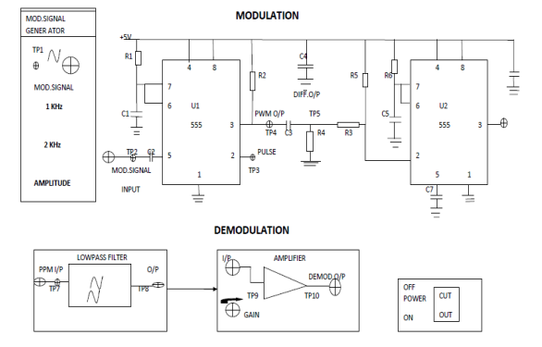

**Modulation:**

1. Connect the circuit as shown in diagram .

a. Connect the modulating signal generator output to modulating signal input (TP1) in PPM block.

b. Keep the switch in 1 KHz position and amplitude pot in max position.

2. Switch ON the power supply

3. Observe the PWM output at TP2, and the differentiated output signal at TP8.

4. Now, monitor the PPM output at TP3.

5. Try varying the amplitude and frequency of sine wave by varying amplitude pot.

6. Repeat Step 5 for frequency of 2 KHz and observe the PPM output.

7. Switch OFF the power supply.

**Demodulation:-**

8. Connect the circuit as shown in diagram2.

a. Connect the modulating signal generator output to modulating signal input (TP1) in PPM block.

b. Keep the switch in 1 KHz position and amplitude pot in max position.

c. Connect the PPM output (TP3) to input of LPF(TP4).

9. Switch ON the power supply

10. Observe the demodulated signal at the output of LPF at TP5

**APPLICATIONS:**

* **Wireless Communication Systems**
* **Fiber Optic Communication**
* **Radar Systems**
* **Remote Sensing and Imaging**
* **Data Storage and Retrieval**
* **Threshold Detection**
* **Matched Filtering**
* **Timing Recovery**
* **Error Detection and Correction**

### Advantages of PPM:

* **Bandwidth Efficiency:** PPM can achieve higher data rates compared to other modulation techniques like Pulse Amplitude Modulation (PAM) for a given bandwidth.
* **Resistance to Noise:** PPM can be more robust against noise and interference because it relies on pulse timing rather than pulse amplitude.
* **Simplicity in Implementation:** PPM circuits can be simpler compared to other modulation schemes, making it cost-effective for certain applications.

### Limitations of PPM:

* **Timing Sensitivity:** PPM requires precise timing synchronization between the transmitter and receiver, which can be challenging in practical systems.
* **Lower Power Efficiency:** Transmitting sharp pulses in PPM can require higher peak power compared to other modulation techniques.

**RESULTS:**

